Website Specifications, Information Design & Taxonomy, Technical Brief
Website name : NovaDrift Safarix

- Website Specifications
Objectives
The objective of NovaDrift Safarix is to promote tourism in Botswana by showcasing the country’s safari-related services and natural attractions. The site aims to inform visitors about the different safari experiences available such as wildlife exploration, guided outdoor activities and nature-based adventures while promoting responsible and sustainable tourism. Through clear and well-organized information, the website seeks to enhance understanding of Botswana’s tourism offerings and offer increased support and appreciation for the country’s unique safari environment.

Business Website Goals
- To promote Botswana’s tourism sector by providing engaging information about its natural attractions while raising awareness of the company’s safari services, including guided wildlife experiences and educational nature activities.
- Highlight key outdoor activities such as game drives, stargazing, camping, mokoro (water-based) excursions and nature photography opportunities.
- Educate visitors about Botswana’s wildlife, landscapes and the importance of responsible and sustainable safari participation.
- Build a credible and informative online presence that explains the company’s focus without providing booking or transaction features.
- Provide structured, easy-to-navigate information that helps users understand the types of safari experiences available and what to expect.
- Encourage engagement by guiding visitors to use the website’s feedback/contact page for questions or information requests related to the offered activities.

Target Audience
- Visitors who come to the website to learn about tourism and safari environments in Botswana.
- Tourists interested in travelling to Botswana for wildlife experiences and outdoor activities.
- Locals who want information about nearby safari areas, conservation and tourism opportunities.
- International audiences researching Botswana as a nature destination.
- Researchers and students seeking educational information about wildlife, conservation and safari eco-systems.
- Nature enthusiasts, including:
  - people who enjoy natural environments
  - wildlife observers
  - hobbyist nature photographers
  - outdoor adventurers
  - conservation-minded individuals.
- Users with mixed technical comfort levels, requiring simple navigation, clear structure, and mobile-friendly access.
- General information seekers who want to learn about Botswana’s natural attractions and safari culture.

Target Audience — Technical Aptitude
- Users accessing the site from a range of devices (smartphones, tablets, computers).
- Users with mixed technical comfort levels who need simple, intuitive navigation.
- Mobile-first visitors who require fast-loading pages and responsive layouts.
- Individuals browsing on low bandwidth or unstable connections.
- Users who benefit from clear text, readable fonts, accessible menus and minimal steps to access key content.

2. INFORMATION DESIGN & TAXONOMY

My Information Structure looks like this:
- Home
- About Botswana Safaris
- Wildlife, Plants & Conservation
  - Animal Profiles
  - Plant Life
  - Endangered Species
  - Conservation
- Experiences
  - Game Drives
  - Hot Air Balloons Safari
  - Camping and Bonfires
  - Mokoro / Water Excursion
  - Nature Photography
  - Bird Watching
  - Guided Nature Walks
  - Stargazing
- Cultural Information
- Visitor Information
- Gallery
- Contact / Feedback
This structure ensures that users can navigate the site quickly and find the information they need with minimal clicks.
The categories are arranged according to user needs:
- Learn what Botswana safaris are → About Botswana Safaris
- Explore nature and wildlife → Wildlife, Plants & Conservation
- Discover available safari activities → Experiences
- Understand local culture → Cultural Information
- Prepare for visiting → Visitor Information

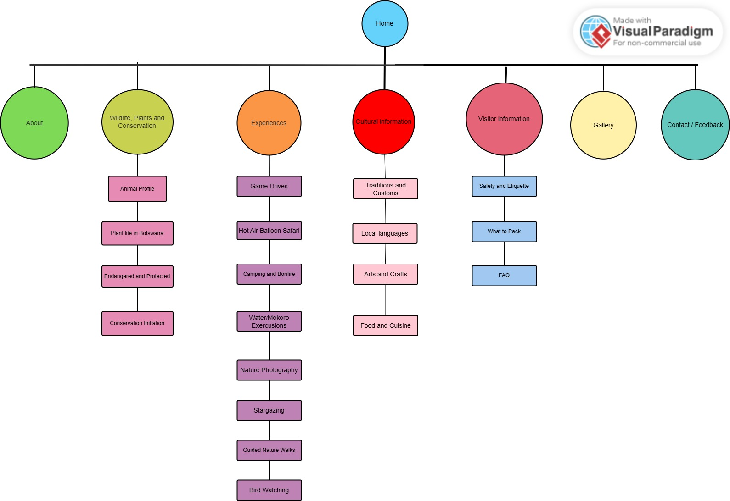
3. TECHNICAL BRIEF
Development Technologies
The website will be developed using the following technologies:
- HTML5 for structuring all web pages and organizing content elements.
- CSS3 for applying layout, colours, typography, spacing, and overall visual design.
- JavaScript for adding light interactivity such as menu toggles, simple animations, and image gallery functionality.
- Bootstrap 5 for implementing responsive design through grid systems, navigation bars, and mobile-friendly components. .

Software Tools
The following tools will be used during development:
- Visual Studio Code (VS Code) as the primary code editor for writing and organizing website files.
- Git for version control and tracking changes throughout the development process.
- GitHub for hosting the project repository and managing source code online.
- GitHub Pages for publishing and hosting the live version of the website.

Graphics & Media Tools
The following tools will be used for handling visual content:
- GIMP or Photopea for image editing, including resizing, cropping, and creating banners or logos.
- Canva for simple graphic design tasks such as icons, overlays, and text-based visuals.
- Online image compression tools (e.g., TinyPNG) to reduce image file sizes and improve website loading performance.

Technical Considerations
- The website will be responsive, ensuring compatibility across mobile devices, tablets, and desktops.
- It will be tested across multiple browsers such as Chrome, Firefox, and Edge.
- Images and media will be optimized to enhance performance and reduce loading times.
- The design will prioritize usability and accessibility, ensuring a smooth user experience.

